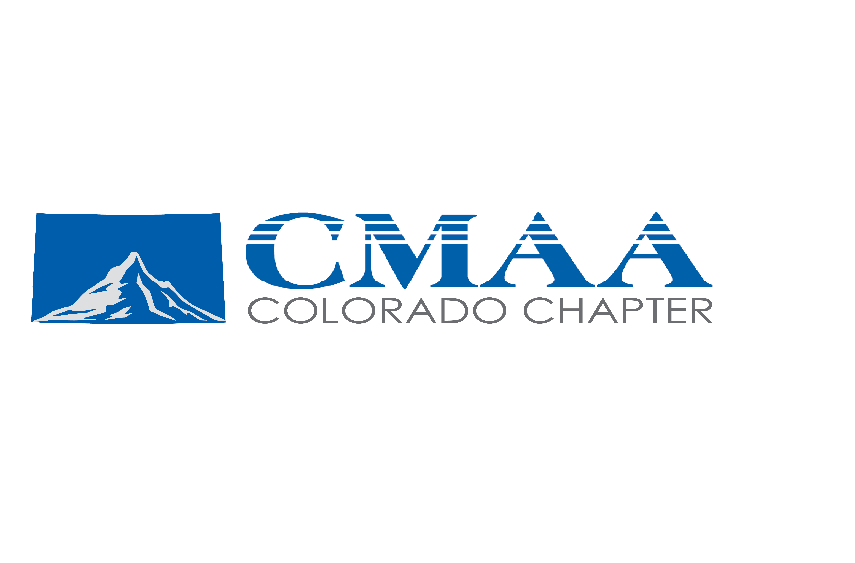

2026 Scholarship Application Package
for Undergraduate and Graduate Student Applicants

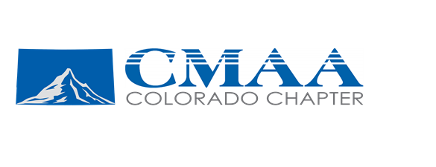
About CMAA Colorado Chapter Student Scholarships
The Construction Management Association of America (CMAA) Colorado Chapter, awards a limited number of scholarships to qualified students to help them defray the costs of pursuing a degree in Construction Management or a related-degree program. The amounts and number of scholarships will vary based on submissions and available funding, with a typical award between $500 to $1,500.

Eligibility Criteria
- Currently enrolled in a construction program or other CM-related degree program.
- Have a minimum of one semester remaining (after award) prior to either undergraduate or graduate graduation.
- Show a strong interest in a career in CM, as demonstrated by a response to the essay question in the application package.
NOTE: Incomplete applications will not be considered by the Colorado Chapter. The application and all associated attachments must be submitted electronically. Hard copies of transcripts, essays and recommendations must be scanned and sent electronically. Hard copy applications and attachments will not be considered.

CMAA Colorado Chapter Scholarship Application Process
All scholarship applications and supporting materials must be submitted directly to the CMAA Colorado Chapter Scholarship Chairperson at cmaacolorado@gmail.com. Be sure to fill out the CMAA Colorado Chapter application completely and submit it with all accompanying attachments electronically no later than Friday, April 3, 2026.

See the Application Checklist on page 4 for guidance in assembling your application. Page 10 of this application should be provided to your academic/faculty advisor for his/her recommendation, which the advisor will submit directly to the Chapter.

CMAA Foundation Scholarship Review Process
- The CMAA Colorado Chapter scholarship selection committee will review all complete applications received from the chapters and from direct submittals and make its recommendations to the CMAA Colorado Chapter Board of Directors for approval. Selected winners will be notified on or about May 15, 2026.
- Scholarship checks will be mailed directly to the student’s college/university upon the student’s acceptance of the scholarship and CMAA’s verification of the student’s enrollment status. If the student has already paid his/her charges to the school and can provide proof thereof in the form of a statement from the school, CMAA will provide the check directly to the student.
- While not mandatory, the scholarship winners are strongly encouraged to attend the CMAA Student Scholarship Night where the recipients will be recognized. Date and location to be announced soon.

CMAA Colorado Chapter Selection Criteria
While regional chapters may use their own evaluation criteria, the CMAA Colorado Chapter scholarship selection committee will consider the following in selecting winners of the national scholarships:

- Academic performance: 40%
- Quality of essay on future plans and scholarship interest: 20%
- Recommendation of faculty advisor: 15%
- Extracurricular activities: 25%
- BONUS: Student member of CMAA National: 5% (National membership is free to students, just go to www.cmaanet.org/membership/individual and select ‘Join Now’ and follow the prompts

Helpful Hints
- All sections of the application, including the Application Checklist, must be completed in full and submitted electronically. An application submitted missing any of the sections and without a signature will be disqualified from consideration.
- The response to the essay must be typed. Be sure to check spelling and grammar carefully. Please remember that your application will be scanned and disseminated to the selection committee electronically; presentation is important.
- The subject line of your email when submitting should include your last name and school name. Please submit one email with all completed sections of the application, in one PDF document including the transcripts, but not the Advisor’s portion as that should be emailed directly to the Scholarship Chair. Applications received with several individual pieces will be returned for consolidation.
- Please keep a copy of your complete application package and request proof of electronic delivery. The returned proof of delivery will serve as verification that your application has been received. No additional notification will be provided.
- Good luck!

Scholarship Application Checklist
To be considered for a CMAA Colorado Chapter scholarship, you must complete the following checklist and include it with the application submission, which is to be forwarded electronically as one PDF document except for the Advisor’s portion.

Completed all sections of the application packet, including:
__ General Information
__ Academic Information, including Current Academic Schedule
__ Extracurricular Activities
__ Employment (If applicable)
__ One Essay on Future Plans and Scholarship Interest
__ An unofficial transcript from each school attended for undergraduate and/or graduate credit, in plenty of time to meet the application submission deadline.
Please supply the following information related to transcripts:

School Name(s) Date of Transcript Request

__ Distribute the evaluation/recommendation form to your academic or faculty advisor and let your advisor know the completed form and one-page statement must be submitted directly to cmaacolorado@gmail.com electronically by April 3, 2026.
__ Proofed the spelling, grammar, and the presentation of the application.
__ Signed and dated the application package.
__ Made a copy of the completed application package.
__ Emailed the application to cmaacolorado@gmail.com by April 3, 2026, with your last name and school name in the email subject line.
__ Obtained electronic proof of delivery.

General Information

First Name
Last Name
Birth Date
Permanent: Street Address
City
State/Province
Postal Code
Country
Phone Number
Email
Current College/University: Name
School Address
City
State/Province
Postal Code
Phone Number
CMAA Member? | Yes | No
CMAA Regional Chapter Affiliation | Yes | No If yes, provide name:
CMAA Student Chapter Affiliation | Yes | No If yes, provide name:
CMIT? | Yes | No
Previous CMAA Foundation Scholarship Recipient?  May 23, 2025 | Yes | No If yes, when?

.

Academic Information

Student Classification for Which You Are Seeking This Scholarship? | Undergraduate Graduate
Student Classification at Time of Application, i.e., 3rd year undergraduate, 1st year graduate
Type of Degree Sought, i.e., BS, MA
Anticipated Graduation Date
Cumulative GPA
Major Field of Study
GPA in Major
Minor (or Concentration) Field of Study

Please list the names, locations, and dates of enrollment for any other colleges or universities you attended while seeking your current degree.

Please list any academic honors and awards you’ve received.

1.

2.

3.

4.

Current Academic Schedule and Transcripts
Please attach your current academic schedule. You also must include an official transcript from each school you have attended for undergraduate and graduate credit.

Both the current academic schedule and transcript(s) must be scanned from originals or provided electronically. Application packages will not be considered complete unless the current academic schedule and official transcript(s) are included in the overall PDF document.

Extracurricular Activities
Please list any extracurricular information you consider to be significant, beginning with the most recent and working back chronologically. Emphasis will be given during judging on activities connected to the CM industry. Do not list every detail about every position or activity. Rather, provide a general sense of your responsibilities and commitment. Attach additional sheets containing other extracurricular activities if necessary.

1. Organization Name
Activity
Date Range
Hours
Description
2. Organization Name
Activity
Date Range
Hours
Description
3. Organization Name
Activity
Date Range
Hours
Description
4. Organization Name
Activity
Date Range
Hours
Description

Employment
If applicable, please enter information regarding your most recent employment. Attach additional sheets containing other employment if necessary.

1. From (month/year): |  | To (month/year):
Company Name
Address
Supervisor Name
Your Position
Duties
Hours Per Week
2. From (month/year): |  | To (month/year):
Company Name
Address
Supervisor Name
Your Position
Duties
Hours Per Week
3. From (month/year): |  | To (month/year):
Company Name
Address
Supervisor Name
Your Position
Duties
Hours Per Week

Essay
Applicants must submit one original essay, addressing the following topic, to be considered for a scholarship. Please do not exceed two, typed, single-spaced pages.

- Please tell us why you are interested in a career in Construction Management.

Applicant Signature
By submitting this application package for a CMAA Colorado Chapter scholarship, I certify that the information contained herein is accurate and factual to the best of my knowledge.

Also, I acknowledge that all decisions of the scholarship committee are final.

Name: Date:

.

Academic/Faculty Advisor Evaluation Form & Recommendation Statement
NOTE TO THE APPLICANT: Fill in the first portion of this form before giving it to your advisor.

Applicant’s Full Name
College/University Name
Department
Academic or Faculty Advisor’s Full Name

NOTE TO ADVISOR: This application (due April 3, 2026) is not complete without your evaluation of the applicant. You are encouraged to provide frank statements about the applicant’s academic competency, achievements and prospect as a future CM/AEC professional in a one-page recommendation letter.

Your evaluation is confidential and will not be shared with the applicant. The judges consider your evaluation to be very important. Your letter will make up 15% of the applicant's total score.

How long have you known this student? |  | In what capacity?
How often do you see this student?

Once completed, please email this form along with your one-page recommendation letter to cmaacolorado@gmail.com. Please indicate the applicant’s last name and school in the subject line of your email. Forms may be scanned and emailed. Recommendation letters should be completed digitally.

